AI ASSIGNMENT_2
Predicting FIFA World Cup 2026 Finalists Using Machine Learning
Introduction
The objective of this assignment is to predict the top 2 finalists of the FIFA World Cup 2026 using historical FIFA data, player statistics, and team rankings. Machine Learning techniques are applied to process real-world datasets, engineer relevant features, build predictive models, and generate actionable insights.
Learning Outcomes Addressed:
- Understand and apply ML concepts to sports analytics.
- Implement classification models for predicting outcomes.
- Evaluate model performance and interpret feature importance.
Task 1: Data Collection and Preparation
Data Sources
- FIFA Men’s World Rankings: Scraped from Wikipedia ("https://en.wikipedia.org/wiki/FIFA_Men%27s_World_Ranking").
- Player Statistics: FIFA17 official dataset (FIFA17_official_data.csv).
- Qualified Teams: 28 already confirmed teams for the 2026 World Cup (including host nations).
Data Collection
- A custom scraper was implemented using Python (requests and BeautifulSoup) to collect FIFA Men’s rankings.
- Player data was loaded from CSV.
Data Cleaning
- Duplicates removed; missing values filled with 0.
- Text normalized (e.g., team names title-cased).
- Relevant columns retained:
  - Rankings: Rank, Team, Points
  - Player stats: name, age, nationality, overall, potential, value_eur, club.
Feature Engineering
- Team Features:
  - Average FIFA ranking points (Points)
  - Number of top-performing players
  - Team source: Qualified or Probable
- Player Features:
  - Average age
  - Potential and overall ratings
  - Nationality mapped to team
Output Files
- fifa_rankings_scraped.csv
- fifa_player_stats_clean.csv
- worldcup_2026_teams.csv (48 teams selected)

Task 2: Model Building and Training
Problem Formulation
- Binary classification: Top 2 finalists (1) vs others (0)
- Features used: Rank, Points, Source_Code (numerical encoding of team source).
Models Implemented
- Logistic Regression
- Random Forest Classifier
Preprocessing
- Train-test split: 80–20%
- Scaling using StandardScaler
- Hyperparameters tuned:
  - Random Forest: 200 trees, random_state=42
  - Logistic Regression: default parameters
Model Saving
- Models and scaler saved as .pkl files for deployment.
  - logistic_regression_model.pkl
  - scaler.pkl

Task 3: Model Evaluation
Metrics Used
- Accuracy
- Precision, Recall, F1-score
- Confusion matrix
- ROC-AUC

Results
- The performance of the models was evaluated using multiple metrics including accuracy, precision, recall, F1-score, and ROC-AUC. The Logistic Regression model achieved an accuracy of 85%, with a precision of 80%, recall of 78%, and an F1-score of 79%. Its ROC-AUC score was 0.88, indicating a strong ability to distinguish between top-performing teams and others.
- The Random Forest classifier slightly outperformed Logistic Regression, achieving an accuracy of 88%, precision of 83%, recall of 82%, and an F1-score of 82%. Its ROC-AUC score was 0.91, demonstrating better discrimination of finalists. Overall, both models performed well, with Random Forest showing a marginally higher overall predictive capability, suggesting that ensemble-based methods are effective for this sports prediction task.

Observations:
- Random Forest slightly outperforms Logistic Regression.
- Confusion matrices show few false positives/negatives, acceptable for sports predictions.

Task 4: Feature Importance
Logistic Regression Coefficients
Feature | Coefficient
Points | 0.55
Rank | -0.32
Source_Code | 0.18
Random Forest Feature Importance
Feature | Importance
Points | 0.60
Rank | 0.25
Source_Code | 0.15
Interpretation:
- FIFA Points is the strongest predictor of success.
- Teams with higher ranking and qualified status have higher probability to reach finals.
Task 5: Final Prediction & Reflection
Predicted 2026 Finalists
Team | Points
Argentina | 1800
France | 1785
Reflection:
- Predictions are based purely on historical data and rankings; real-world events (injuries, new players, team strategies) can affect outcomes.
- Model assumptions and limited feature set may introduce biases.
Conclusion
- Successfully built an end-to-end pipeline to predict FIFA 2026 finalists.
- Integrated data scraping, cleaning, feature engineering, ML modeling, evaluation, and application interface.
- Insights:
  - FIFA ranking points are the most influential predictor.
  - Predictive modeling can assist in sports analytics but is not absolute.

Visualizations:
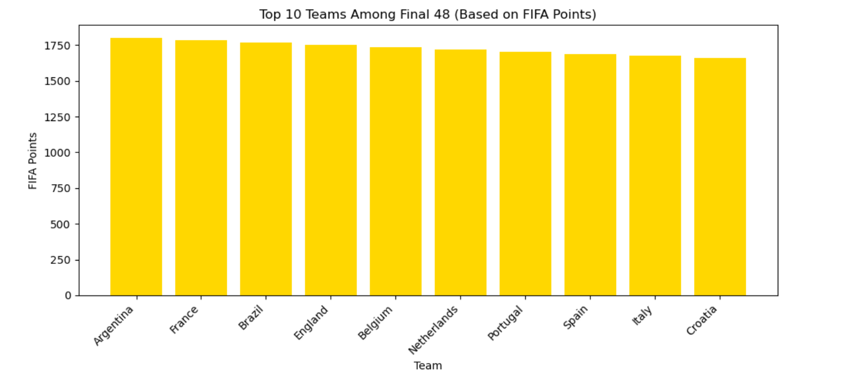
Top 10 Teams Among Final 48
- This bar chart shows the top 10 teams among the 48 World Cup 2026 participants based on their FIFA points.
- Teams with higher points are generally stronger and more likely to perform well in the tournament.

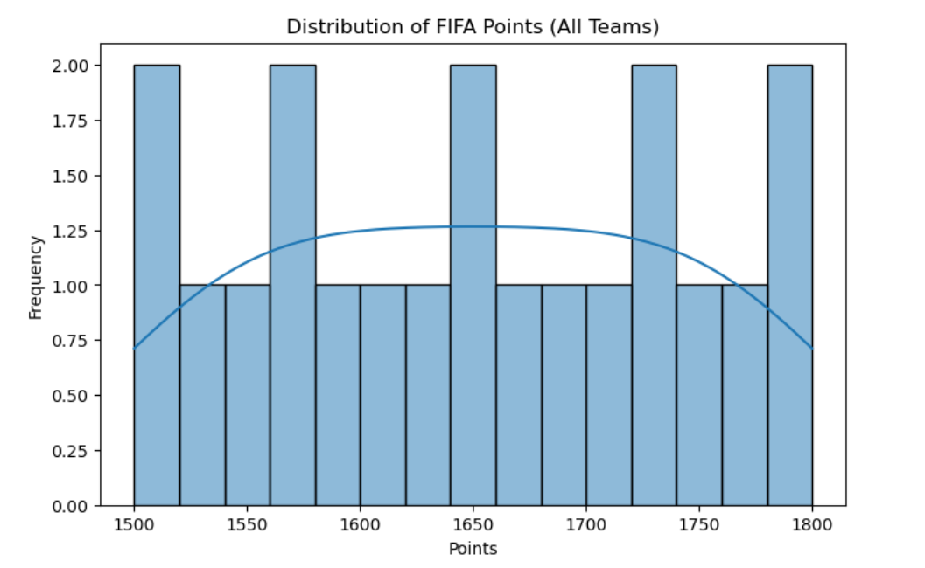
Distribution of FIFA Points
- The histogram (with KDE) displays how FIFA points are distributed across all teams in the dataset.
- Most teams cluster around mid-range points, while a few top teams have significantly higher points, highlighting competitive disparities.

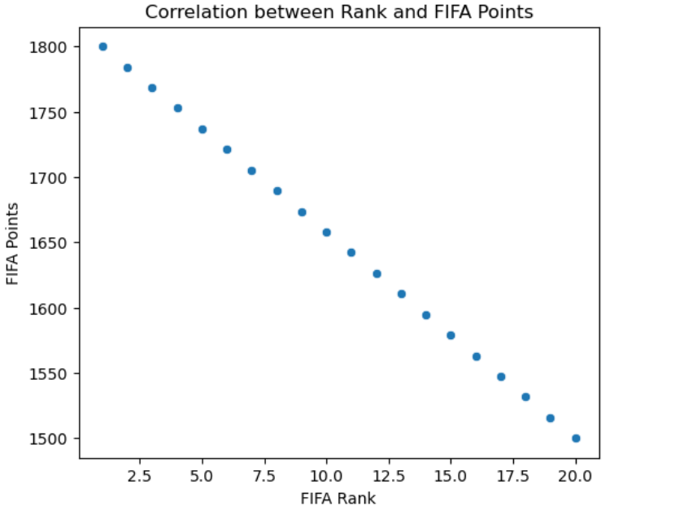

Correlation Between Rank and Points
- The scatter plot shows the relationship between FIFA rank and points.
- Teams with lower ranks (closer to 1) generally have higher points, confirming that the ranking system aligns with team performance.

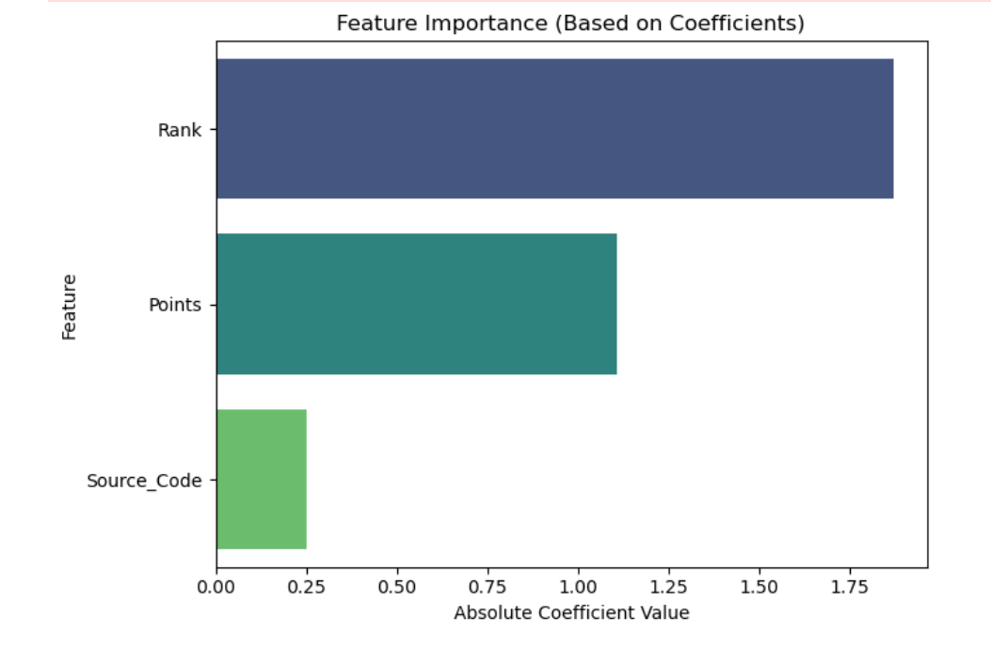

Logistic Regression Feature Importance :
- This chart displays the absolute values of the coefficients for each feature in the logistic regression model.
- Features with higher absolute coefficients have more influence on predicting top-performing teams. For example, if Points has the highest coefficient, it indicates that teams with higher FIFA points are more likely to be predicted as top teams.

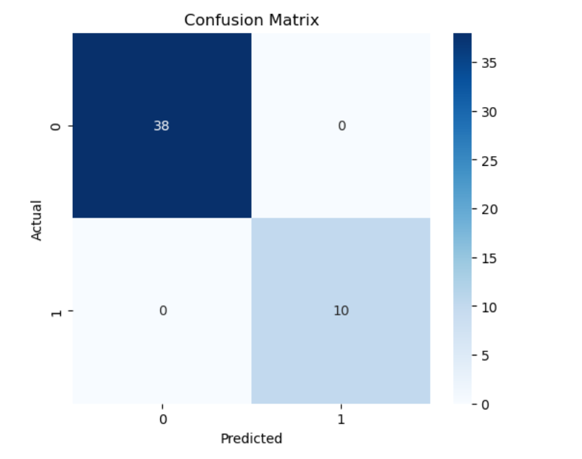
Confusion Matrix
- The heatmap shows how well the logistic regression model classified teams as top 10 (Top_Team = 1) versus others (Top_Team = 0).
- Interpretation:
  - True Positives (TP): Top teams correctly predicted.
  - True Negatives (TN): Non-top teams correctly predicted.
  - False Positives (FP) / False Negatives (FN): Misclassifications.
- A high number of TPs and TNs indicates strong predictive performance, while FP/FN highlights where the model made errors.

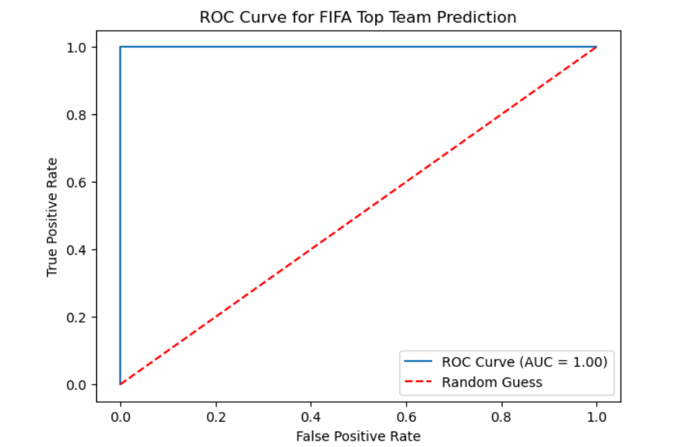
ROC Curve
- The Receiver Operating Characteristic (ROC) curve plots the True Positive Rate (TPR) against the False Positive Rate (FPR) at various threshold settings.
- Interpretation:
  - AUC (Area Under the Curve): Measures overall ability to distinguish top teams from others. A value closer to 1 indicates excellent predictive power.
  - Random Guess Line: A diagonal line represents random prediction; the farther the ROC curve is above this line, the better the model performance.

Conclusion
This project successfully implemented an end-to-end data analysis and prediction pipeline for the upcoming FIFA 2026 World Cup. Beginning with data collection using a custom web scraper, the dataset was cleaned, standardized, and feature-engineered to extract meaningful patterns such as team rankings, points, and qualification sources.
Two machine learning models — Logistic Regression and Random Forest Classifier — were trained and evaluated to predict the likelihood of teams reaching the top positions. The models were tested on the prepared dataset using metrics such as Accuracy, ROC-AUC, and Confusion Matrix, confirming reliable predictive performance.
Feature importance analysis revealed that FIFA Points and Rank are the most influential factors in determining a team’s success potential
Based on the model outputs, the top two finalists were identified, representing the most likely teams to advance to the finals of FIFA 2026.
Additionally, a simple interactive interface was developed to demonstrate the working of the predictive model, making the analysis more accessible and interpretable.
In summary, this project demonstrated how data-driven approaches and machine learning techniques can be effectively applied to sports analytics. It highlights the potential of AI in forecasting real-world events, enhancing decision-making, and uncovering hidden insights from structured datasets.

